May 2017

Dear Principal,

Glenlola Collegiate is pleased to announce the 6th Ulster Schools’ Derby competition which will be held at Gransha Equestrian Centre, Bangor in aid of Macmillan Cancer Support. Your participation and support for this event is greatly welcomed.

**Show date:**

Thursday 21 June 2018

Classes will include:

|  |  |  |
| --- | --- | --- |
| **Class** |  | **Max. Height of Fences** |
| 1 | Individual Primary | 60cm |
| 2 | Individual Newcomer | 60cm |
| 3 | Novice Individual/Team | 75cm |
| 4 | Open Individual/Team | 95cm – 1m |

**Entry Fees**

£50 per team

£15 per individual

Please find enclosed competition information and rules, entry form and sponsorship form. We would appreciate it if you could pass this information on to a relevant member of staff or the Show Jumping/Equestrian Team representative.

Gransha Equestrian Centre provides insurance cover for this event and a paramedic will be in attendance.

Yours sincerely





Nikki Sinnerton and Judith Hughes (Show Organisers)

@UlsterSchDerby



Competition Information and Rules

**VENUE:** Gransha Equestrian Centre

10a Kerrs Road  
Bangor  
Co Down  
BT19 7QD

**THE PROPRIOTER WOULD ASK THAT DOGS ARE NOT BROUGHT TO THE EVENT**

**How will the competition be judged?**

* Each competitor will be required to jump one round. The course will consist of working hunter fences, followed by portable/solid cross country fences and will finish with show jumps. Competitors will be asked to jump a maximum of 20 fences.
* The course will mostly be contained within an outdoor, all-weather arena although some of the course may require obstacles to be jumped in an adjoining grass paddock.
* The show jumping phase of the course will be **timed**.
* **Rider and horse/pony must ride the working hunter and cross country phases in a controlled, steady manner as these phases are not timed. Disqualification will result if a rider is deemed to ride these phases inappropriately.**
* Times from the show jumping phase will be used for placings in the event of two or more teams/individuals being on equal scores.
* The competitor/team with the least amount of faults and the quickest time/s will be the winner.
* Competitors must go between the finish posts/flags to qualify a time.
* Eliminated riders will not be permitted to continue jumping and will be asked to leave the arena upon elimination.

**CLASS 1 - INDIVIDUAL PRIMARY**

* This is for individual competitors who are not part of a school team.
* This class is open to **PRIMARY SCHOOL** pupils only.
* Primary School competitors can compete in any of the classes except Class 2.
* The same rider/animal combination cannot compete more than once.



**CLASS 2 - INDIVIDUAL NEWCOMER**

* This class is for Key Stage 3 pupils only and aimed at riders representing their School for the first time.
* Competitors taking part in this class cannot take part in any other class.
* Entries for this class are limited to a maximum of 20 riders. If this class is over-subscribed a waiting list will be employed.
* Entries will be taken on a first come, first served place with full payment.

**CLASSES 3 AND 4 - NOVICE (CLASS 3) AND OPEN (CLASS 4)**

* Classes are open to anyone aged 19 or under and in full time education.
* All competitors in these classes are eligible for individual prizes.
* Each team must consist of at least 2 riders with a minimum of 3 different combinations of rider/pony.
* The 3 lowest scores and times, of each team, will count.
* Post-primary School competitors can enter both the Novice and Open classes but the same rider/animal combination cannot compete more than once ie. A rider can compete in both the novice and the open class but this must be on a different animal.
* Team members should be entered in the order they wish to compete.
* Competitors will jump in their teams, one after the other.
* The **same team cannot compete** in both the Novice and Open team competition.
* Schools may join together to form a mixed team. Only teams with all members from the same school can qualify for first place in the Open and Novice classes. Subsequent places are open to all teams.
* A horse or pony may be ridden by two riders, from the same School, in one class only if it is fit to do so. A horse/pony can compete no more than twice.

**TEAM SELECTORS SHOULD MAKE SURE THAT COMPETITORS ARE COMPETENT RIDERS**

**GENERAL RULES**

* All riders **must** wear regulation safety hats and back protectors. These must be brought to the tack inspection. Hoodies are not permitted whilst on horseback.
* All competitors must report to the ‘tack inspector’ at their stated time. The tack inspector will check the safety of tack and will judge the ‘turnout’ at the same time. If tack is deemed to be unsafe, competitors must make the necessary amendments and re-present themselves to the tack inspector. If a competitor fails to present themselves to the tack inspector, or is unable to amend any unsafe tack, they will not be allowed to compete.
* A responsible adult must be appointed by the School to act as Chef d’equipe and be present with the team/individual on arrival and during the competition. The Chef d’equipe is responsible for the conduct of his/her team/individual at all times.
* **JUDGES AND STEWARDS DECISIONS ARE FINAL.**
* Any queries regarding results must be made within 30 minutes of completion of the class.
* Any rider or school representative showing unsporting behaviour will automatically be disqualified.
* Late entries may be taken at the discretion of the organisers.
* The organisers wish to remind competitors and spectators that equestrian activities can be dangerous.

**TOP FUNDRAISER**

This event is a fundraiser for Macmillan Cancer Support in memory of long-time supporters John and Gwyneth Wilkinson. An **Apple iPod Shuffle** will be awarded for the top fundraiser on the day. The winner of this prize will be announced before the start of the Open competition.

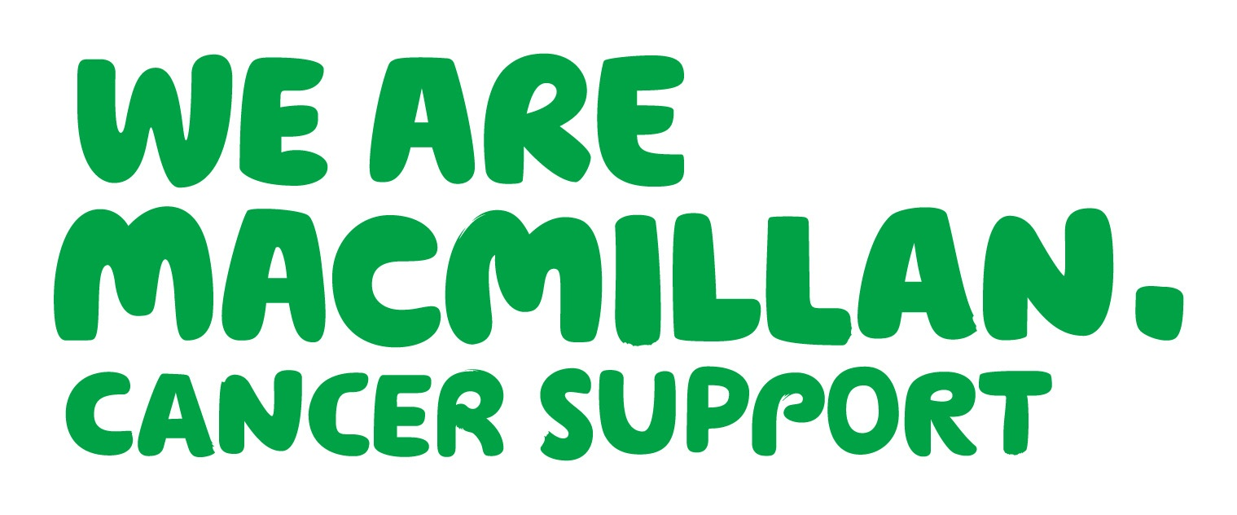



**TABLE OF FAULTS FOR COMPETITION**

**Knockdown** 4 faults

**First disobedience** 4 faults

**Second disobedience** 8 faults

**Third disobedience** Elimination

**Fall of horse/pony or rider** Elimination

**Riders will be asked to leave the arena immediately after their elimination.**

**TIMINGS**

INDIVIDUAL PRIMARY 8.30 am

NEWCOMER 10.00am

NOVICE 11.30am

OPEN 3.00pm

These timings are **approximate** and will be dependent on number of entries received. It is the rider’s responsibility to arrive at the venue with sufficient time.

Times will be posted on <http://glenlola.net> by Tuesday 19 June.

**Please make cheques payable to Glenlola Collegiate School**

If the event is over-subscribed, competitors’ entries will only be accepted upon payment of entry fees. If entry fees are not paid before their starting time, the competitor will not be allowed to compete.

Entry forms should be attached to the email address below with all the relevant information included.

**ALL ENTRIES SHOULD BE EMAILED TO: jhughes667@c2kni.net**

Payment for entries can be made on the day. Failure to attend will result in an invoice being sent to the school.

**NB: CLOSING DATE FOR ENTRIES WILL BE FRIDAY 15 JUNE 2018**

**PRIZES**

**Teams & Individuals**

1st to 6th rosettes

1st – 3rd prizes

**Top fundraiser**

Apple IPod Shuffle

**Turnout**

1st prize

**For further enquiries and information contact:**

Nikki Sinnerton: 02891 475340 (Daytime) or [nsinnerton018@c2kni.net](mailto:nsinnerton018@c2kni.net)

Judith Hughes: 02891 475340 (Daytime) or [jhughes667@c2kni.net](mailto:jhughes667@c2kni.net)

1. **TIMES:**

Times will be posted on <http://www.glenlola.net> on Thursday 6 June.

**FOR FURTHER ENQUIRES AND INFORMATION CONTACT:**

**Nikki Sinnerton: 02891 475340 (Daytime) or nsinnerton018@c2kni.net**

**Judith Hughes: 02891 475340 (Daytime) or jhughes667@c2kni.net**

